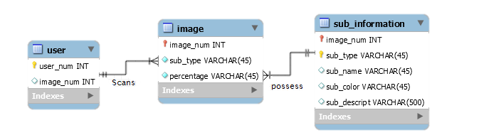**Entity Relationship Diagram (with Data Dictionary)**

